**Assignment 2 – Registration**

**Part 1: Sift feature matching**

In this part of the assignment we have used openCV’s SIFT library to extract the key-points and their descriptors.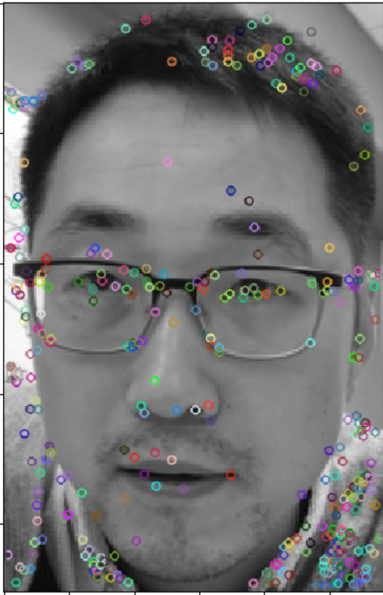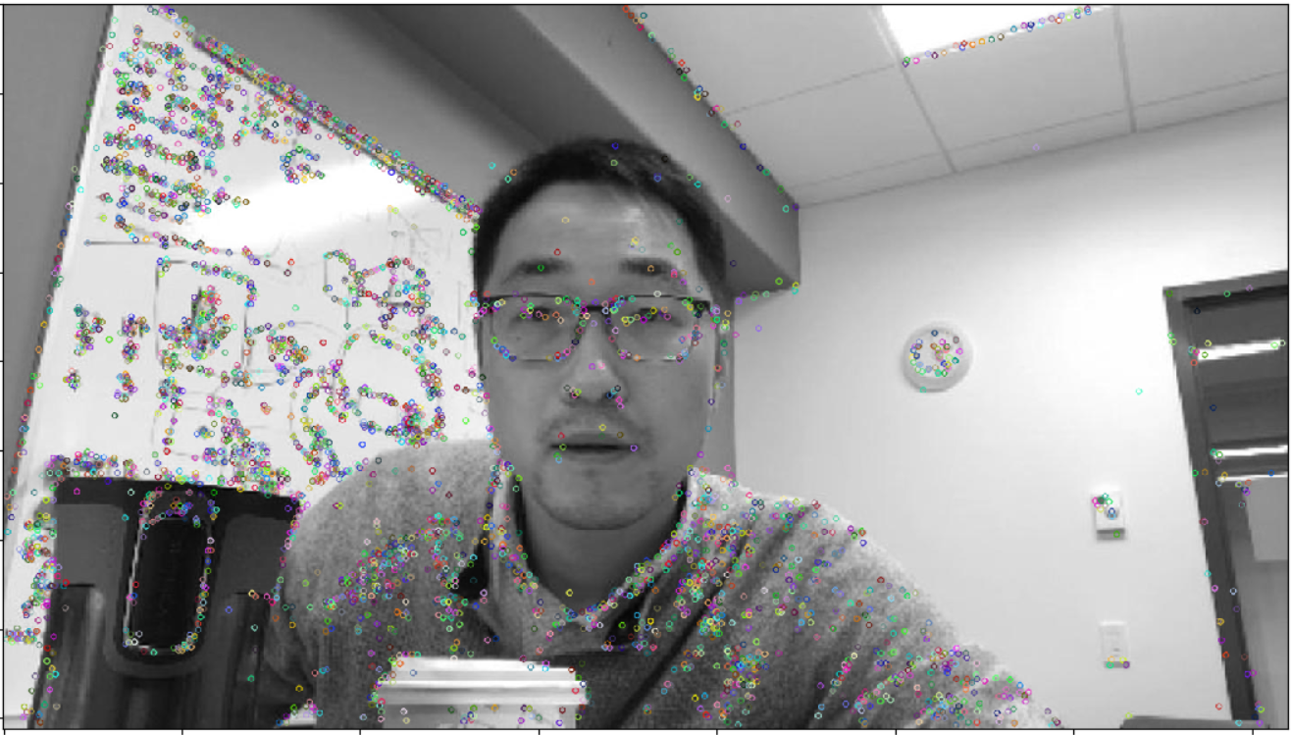

SIFT features

Applied k-nearest neighbors on these points to get two closest neighbors for all the keypoints from template to target image. After filtering these matches with ratio test with ratio parameter of 0.75, we got 114 correspondence points.

**Part 2: Feature based alignment**

In this part we have computed affine transform from template pixel to target pixel using RANSAC algorithm. After trying out many iterations over RANSAC parameters, highest number of inliners were obtained with error threshold value of 6 and iterations value of 10000. Number of inliners found–17. Also implemented warp_image method to warp target to template’s size given a transform matrix. Following images are of inliners and the warp result of the produced affine transform.

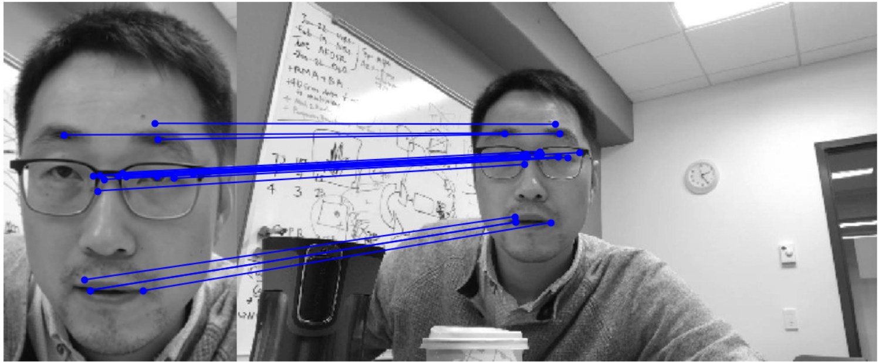 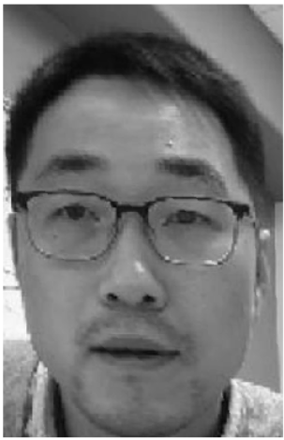

#inliners warped image

**Part 3: Inverse compositional image alignment**

This technique is a performance improvement over Lucas Kanade’s algorithm of image alignment, where we try to minimize the intensity error between the template and the warped image. It is better in terms of performance because we have to calculate the Jacobian of the initial warp, gradient of template, steepest descent images and hessian only once at the start of convergence iterations. We implemented a method which takes template, target and initial affine transform and runs inverse compositional alignment algorithm to refine the transform. Here are the results for one such execution.

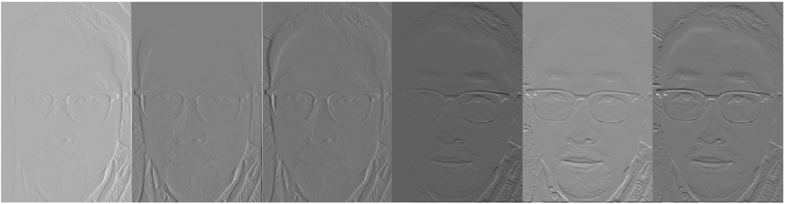

Steepest descent images

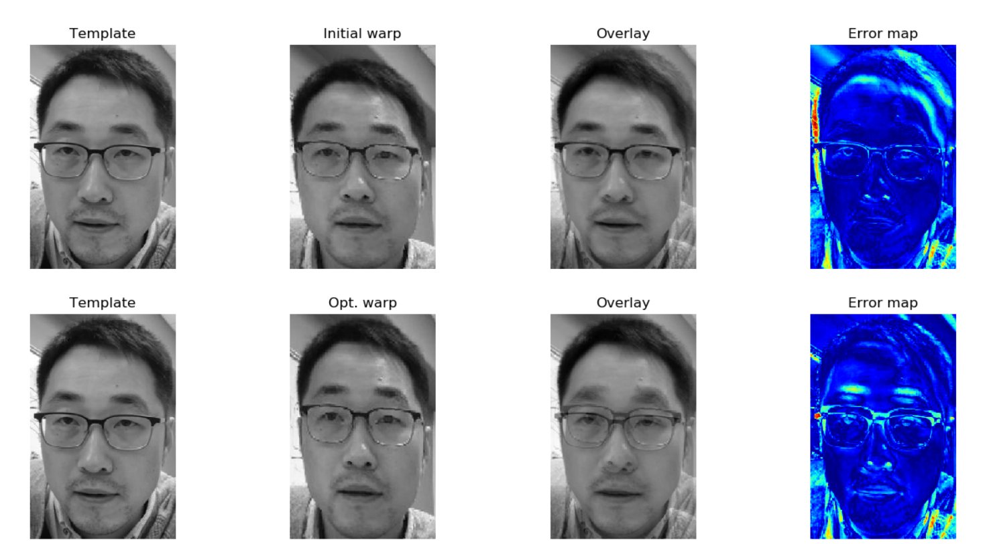 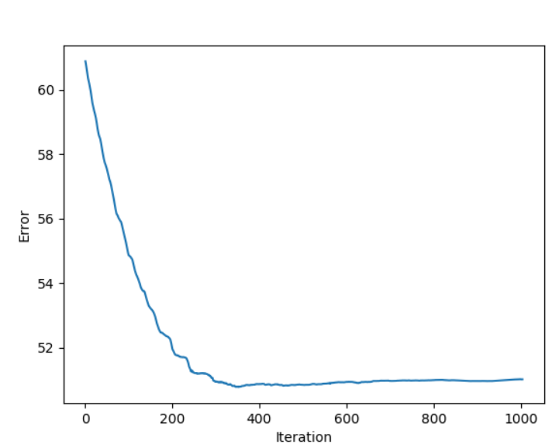

Error maps Error convergence

**Part 4: Multi frame tracking**

We run above algorithm for each consecutive frame, with updating the initial affine transform with the refined transform of the last step. Current loop condition is ‘norm(dp) > 0.001 and iterations < 1000’

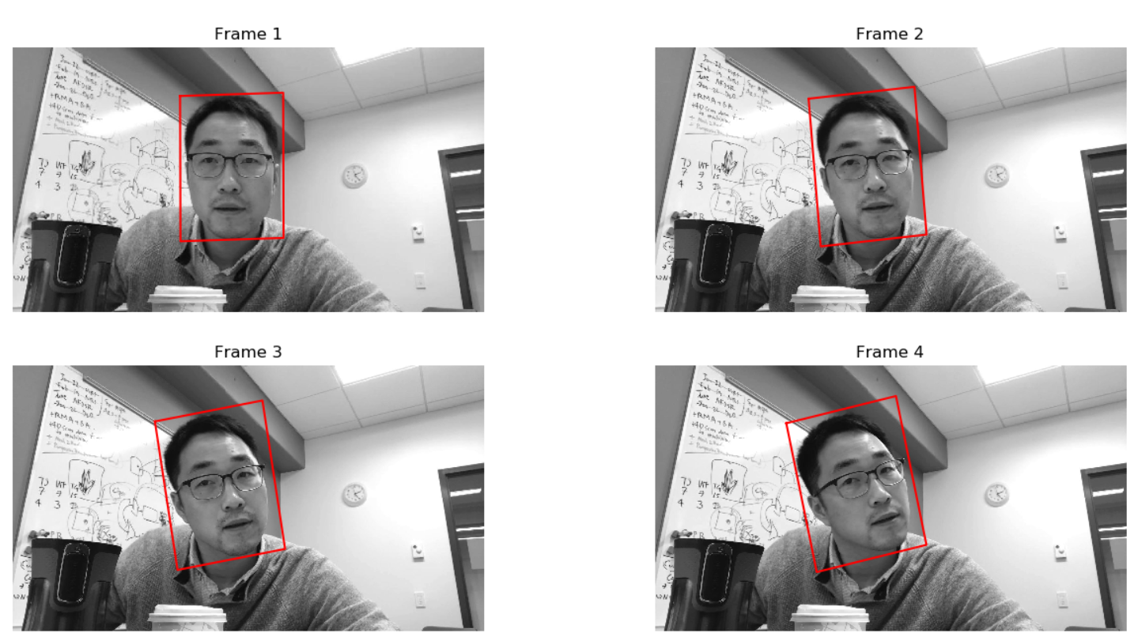

Results of the track_multi_frames method